

What if there is a problem?
This study will involve additional ultrasound scans and external measurements of your newborn baby. The likelihood of harm to you or your baby from the study is negligible. If you do have concerns about the way you have been approached or treated during the course of the study, you can contact the study unit coordinator. You may also follow the normal NHS complaints procedure. You can find out more information about this at:
http://www.nhsdirect.nhs.uk/articles/article.aspx?articleId=569.
You may withdraw from the study at any time. This would not affect your care in any way. Any stored data that identifies you would be destroyed.

What will happen to the results of the research study?
The results will be written up for worldwide distribution, publication in scientific journals and presentation at international meetings. We would be happy to provide you with a copy of the papers after publication if you wished. Your name will not appear in any report or publication. Some of the data from the study may be included in the PhD thesis of one or more of the researchers. Your identity will be protected at all times.
Will my taking part in the study be kept confidential?
Our system administrator, who has a duty of confidentiality to you, will be the only person able to identify you. Your results and pictures would be held anonymously in a database to which only the research team will have access. Authorised representatives from the University of Oxford may look at the anonymised results to check that the study is being performed correctly. No individual participants will be identified when the results of the study are published. In clinical research such as this, it is our responsibility to inform your GP that you have agreed to take part in this study. This is to ensure that you are fit and healthy at the time of participation and remain well during the course of the study.

Patient Information Leaflet

INTERGROWTH-21st Study
We would like to invite you to volunteer in a research study on normal fetal and newborn growth that is being carried out in the Nuffield Department of Obstetrics & Gynaecology, at the University of Oxford and the John Radcliffe Hospital Women’s Centre. To help you decide if you would like to take part, this leaflet will explain why the research is being done and what it would involve for you. Please take the time to read the following information carefully and do ask us if you would like some more information.

For further information:
If you have any further questions please do not hesitate to contact Fenella Roseman, our Research Midwife, on 01865 857650 / 07837846234 or at fenella.roseman@obs-gyn.ox.ac.uk or Nuffield Dept. of Obstetrics and Gynaecology, University of Oxford, John Radcliffe Hospital, Women’s Centre, Level 3, Headington, Oxford OX39DU.
You can find our website at www.intergrowth21.org.uk.

Thank you for taking the time to read this leaflet!

V 05. 14.04.09
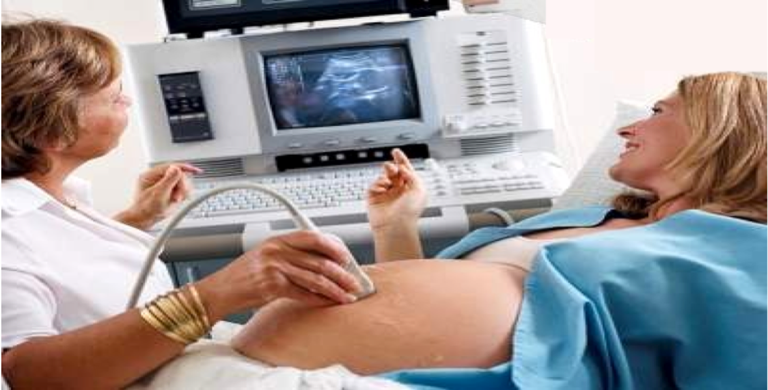
If you agree to take part in the study, you would be offered six ultrasound scans at 5 weekly intervals. Apart from these extra scans, you would receive the routine antenatal care. If your baby is born early (less than 37 weeks) we will monitor the growth of your baby for 8 months. This would involve monitoring the health of your baby and measuring his or her weight, length and head circumference every 2 weeks for the first eight weeks, and then every month until eight months after birth.

What are the possible benefits of taking part?
Taking part in this study would not benefit you directly. However, the information obtained from this study will enable us to create unique fetal and newborn growth charts for the first time. These will be used internationally and potentially save the lives of many babies and newborns. In addition, you have the opportunity to have 5 extra scans during your pregnancy. You may claim back your travel expenses for these additional scans.

What is the purpose of the Study?
The aim of this unique study is to chart the growth patterns of unborn babies and newborns all over the world and create an international standard for healthy growth. Currently, your baby’s growth before birth is assessed by comparing the size of its head and tummy with ultrasound charts obtained from the measurements of a very small number of babies in selected hospitals. These existing charts were made from small-scale studies in Europe and the USA and may not be appropriate for use internationally. This new study will take place in eight countries on five continents over a five-year period. We hope to recruit around 4000 volunteers, 500 of whom will come from Oxford. What makes this study unique is it size and the fact that we will be assessing healthy mothers and babies all over the world. We hope this research will shed light on the growth pattern of healthy unborn babies and newborns across the world. Our purpose is to set a new international ‘gold’ standard for growth.

Why have I been invited?
You have been invited to take part because you are aged between 18 and 35, are fit and healthy, have regular menstrual cycles, have conceived spontaneously and have a gestational age of less than 14 weeks now.

Do I have to take part?
It is up to you to decide whether or not you wish to take part. Your decision will not affect the care you receive in any way. If you have any questions or concerns after reading this leaflet, our research midwife will be happy to answer them. You can also call her on the number on the front of this information leaflet.

What will happen if I don’t want to carry on with the study?
You may withdraw from the study at any time. This would not affect the care you get in any way. Any stored data that identifies you would be destroyed.

What will I be asked to do?

Who is organising and funding the research?
The research is being carried out by the Nuffield Department of Obstetrics and Gynaecology. The study is funded by the Bill and Melinda Gates Foundation.
Who has reviewed the study protocol?
Research is reviewed by an independent group of people called a Research Ethics Committee to protect your safety, rights, well being and dignity. This study has been reviewed and approved by Oxfordshire Clinical Research Ethics Committee C.

